
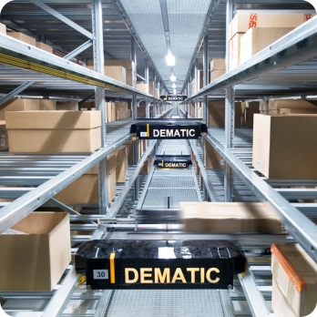
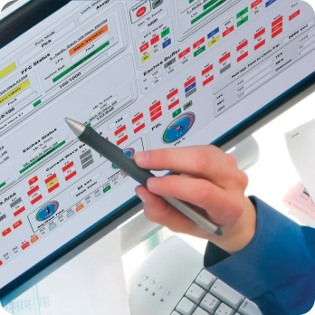
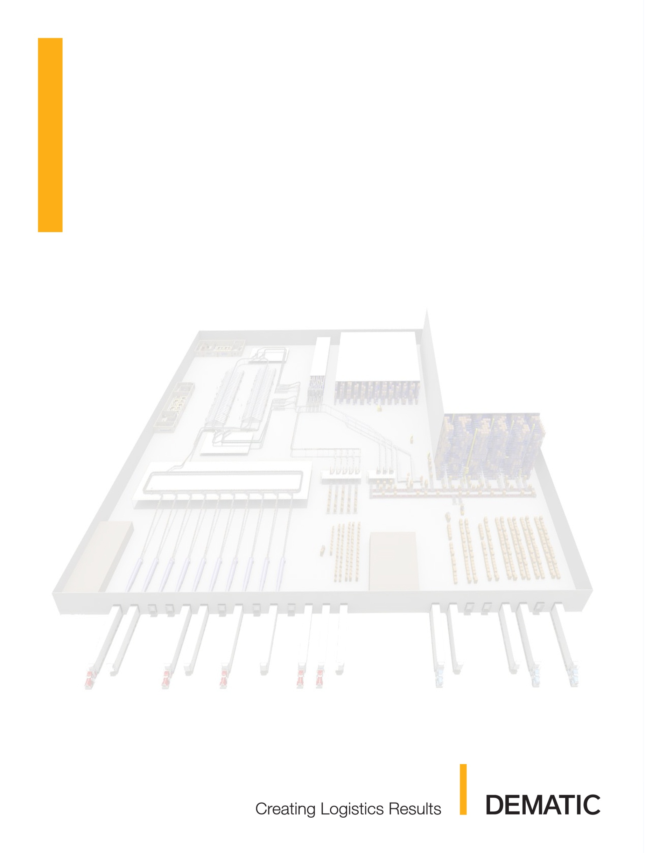
Lifetime Brands
Robbinsville, NJ

Project #128175
Director IT
Software Functional Specification 1.0.1
06-May-2014

Information in this document is subject to change without notice. No part of this document may be reproduced or transmitted in any form or by any means, electronic or mechanical, for any purpose, without the express written permission of Dematic Corp.
© 2014 Dematic Corp. All rights reserved
Dematic confidential information. Not for further distribution.
This document contains confidential information, trade secrets and/or know-how which is the property of Dematic Corp., and may not be disclosed to any third party without the written permission of Dematic Corp.
Product and company names herein may be the trademarks of their respective owners.
Dematic Corp. shall hereinafter be referred to as Dematic.
Dematic Corp.
507 Plymouth Avenue
Grand Rapids, MI 49505
616-913-6200
800-530-9153
www.dematic.us

Release Dates
Release Date | Description
2014-May-06 | Initial Release
2014-May-15 | Revised after on-site review with Lifetime Brands Team

Contents
1 Introduction 6
1.1 Purpose 6
1.2 Related Documents 6
2 Scope of Work 7
2.1 Responsibilities 7
2.1.1 Dematic Corp. 7
2.1.2 Lifetime Brands 7
2.2 Director IT 7.0 Computer System Requirements 10
2.2.1 Director IT 7.0 Software 10
2.2.2 Director IT 7.0 Servers 10
2.2.3 Pick to Voice Hardware Descriptions 10
2.2.4 Pick to Voice Hardware List 12
2.2.5 Documentation 13
2.2.6 Training 13
3 System Architecture 14
3.1 Computer Architecture 14
4 Functional Description 15
4.1 Description of Operation 15
4.1.1 WMS and Dematic System Communication 15
4.1.2 PickCart Building 15
4.1.3 Operator Log-in and Log-out 16
4.1.4 PickCart Processing 16
4.1.5 PickCart Completion 20
4.1.6 Expert Pick Modes 21
4.2 Location Naming Conventions 21
5 Performance Description 23
5.1 Director IT 7.0 Response Times 23
5.2 Data Storage and Clean Process 23
5.3 System Backup and Restore 24
6 Graphical User Interface 25
6.1 System Overview 25
6.2 System Progress 27
6.2.1 Zone Progress 28
6.3 Outbound Container - Pick 29
6.4 Location Information - Pick 30
6.5 Picking Reports 32
6.5.1 Statistics By Operator 32
6.5.2 Statistics By Section 34
6.6 Picking KPIs 36
6.7 Picking Dashboard 39
7 Appendix 43
7.1 Appendix A – TCP/IP Addresses 43
8 Signatures 44

Introduction
An order fulfillment system is being installed at the Lifetime Brands facility in Robbinsville, NJ. The Dematic iQ solution provides the order fulfillment functionality, leveraging the Director IT platform.
Dematic will install the computer-based Director IT picking system that will interface to the Lifetime Brands Warehouse Management System (WMS) and the lower level devices.

Purpose
This Functional Specification defines the Director IT picking system being installed. An overview is provided, system interactions are defined, and the deliverables (hardware, software, and documentation) are listed.
This specification also serves as a method of communication between Lifetime Brands and Dematic Corp. It is provided for customer review. Feedback is used by Dematic Corp. to revise the specification as necessary to ensure an accurate understanding by all concerned parties of the Director IT computer system requirements. When the specification reflects a satisfactory system specification, signed approval of the document is required.

Related Documents
- Proposal
- Host Interface Specification (current version)

Scope of Work
The scope of work includes providing software that communicates with the Lifetime Brands Host system via TCP/FTP, software that communicates to the Talkman units to control order fulfillment activities, the user interface as defined in the Director IT User Manual, commissioning of software as per project management schedule, training on the use of the provided software and training on the maintenance of the system.

Responsibilities
This section describes what Dematic Corp. and Lifetime Brands will each provide to ensure an efficient and productive implementation of the Director IT 7.0 computer system.

Dematic Corp.
Dematic Corp. will provide the following:
- The Director IT 7.0 software executables and configuration (Source Code is NOT provided).
- Modifications to the Director IT 7.0 application software to include the custom features defined in this specification.
- A MessageDistributor interface to the Lifetime Brands WMS.
- Remote software support via VPN.
- User Manual.
- Training of the operating personnel on the Director IT 7.0 computer system and associated peripherals.
IMPORTANT: Proper operator training is essential to successful operation of the system. Operators must be aware that their input does affect the material handling system.

Lifetime Brands
Lifetime Brands will provide the following:
- Review and approve (by 16-May-2014) this functional specification.
- Review and approve (by 16-May-2014) the Host Interface Specification.
- RF network covering all picking areas with 802.11b access points.
- Location and power for all of the Talkman base units for charging and storage of backup batteries.
- Man-readable check digits and location barcodes installed at each location.
- Verification that the network functions properly. If the network has a high traffic level and the performance of the Director IT 7.0 computer system is affected, Lifetime Brands is responsible for providing hubs, repeaters, etc. necessary to optimize the performance of the order fulfillment system.
- TCP/IP connectivity information such as: network settings, TCP/IP addresses, subnet masks, gateway and any other needed information.
- MessageDistributor interface from the Lifetime Brands WMS over Ethernet.
- Virtual Server including Windows Server 2012 OS and SQL Server 2012 Database. Backup and disaster recovery of this virtual server is the responsibility of Lifetime Brands.
- Work surfaces and chairs to be used for commissioning.
- At least 250 test cartons with a corresponding test file and labels for those cartons.
- One dedicated voice telephone line for the exclusive use by Dematic Corp during commissioning.
- Provide dedicated on-site technical support to test host interface during the SAE commissioning effort.
- Static Ethernet IP Address, Subnet Mask, Default Gateway, etc. for virtual server.
- Point-to-Point VPN connectivity from the Dematic Customer Service Network to the virtual server.

Site Readiness
The Director IT 7.0 system requires an operating environment consistent with the requirements listed in the table below.
- Lifetime Brands WMS ready to test downloading and uploading by 23-Jun-2014.
- Test Data with matching Product for Commissioning Testing
- Test Data with matching Product for Acceptance Testing
- Operations Personnel for Training sessions

Wired LAN Requirements
Lifetime Brands is responsible for providing a TCP/IP Ethernet network segment (100baseT, IEEE 802.3) with drops necessary for the virtual server. All connectivity hardware and software on the WMS is the responsibility of Lifetime Brands.
It is recommended, but not required that Director IT 7.0 system be installed on a unique subnet of the Ethernet System to allow for isolation and troubleshooting of this and other systems on Lifetime Brands Ethernet Backbone.

Network Security
Lifetime Brands is responsible for managing all network security in terms of prevention, detection, and response.
Network security may include (but is not limited to): physical security, packet screening; vulnerabilities; firewalls; authentication; authorization, and other security issues that may potentially impose risks or threats.

RF Wireless LAN Network
Lifetime Brands will supply RF coverage of suitable type for communication with the voice terminals in the proposed system. The RF network supplied must be compatible both with the mobile voice terminals and also with the Director IT 7.0 Servers.
The basic wireless LAN requirements are as follows:
- IEEE 802.11b or IEEE 802.11g (802.11b compatible) wireless LAN
- Must be WiFi certified for interoperability
- Data Rate restriction to use 2Mbps and 5.5Mbps only
- Dual antenna diversity enabled
- 30mW-50mW output power
- Security should be WEP minimum, but WPA or better recommended
:INFO: Vocollect devices will NOT support WPA2 with TKIP encryption.
- Filter out extraneous broadcast traffic
:INFO: An RF site survey is recommended to optimize and verify WLAN coverage, and to insure the WLAN environment is clear of any unintentional or outside interference. This RF site survey is the responsibility of Lifetime Brands and is not included in this scope.

Director IT 7.0 Computer System Requirements

Director IT 7.0 Software
Lifetime Brands and Dematic will provide the following Computer Software for the Director IT 7.0 applications:
Table 1 Server Software by Lifetime Brands
Description | Quantity
Windows Server 2008R2 | 1
SQL Server 2012 Standard Edition | 1
Table 2 Server Software by Dematic
Description | Quantity
Director IT 7.0 Software (Runtime only) | 1
1st year Software Maintenance | 1
VoiceApplication in both English and Spanish | 1

Director IT 7.0 Servers
Lifetime Brands will provide a virtual server for the Director IT 7.0 system. At a minimum, the server should have 4 CPU cores, 12 GB Memory, and 180 GB HD (80 GB c:\; 100 GB e:\)

Pick to Voice Hardware Descriptions

Voice Terminal Assembly
The voice terminal assemblies will consist of a Vocollect A710 terminal, terminal belt, SRX2 Bluetooth headset and Motorola RS507 Bluetooth ring scanner.
Dematic recommends for hygiene reasons that each Operator be issued their own terminal belt, headset and scanner finger strap.

A710 Voice Terminal
The Talkman A710 is a wireless-only device used in an environment where operators will be using Bluetooth-enabled headsets and peripheral devices.
Figure 1 Vocollect A710 Voice Terminal
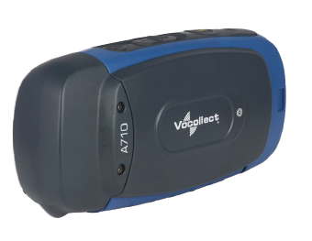

Terminal Belt
Dematic recommends each worker be issued a personal belt and terminal clip. An assigned belt allows an Operator to customize the belt size only once.

SRX2 Bluetooth Headset
Each terminal assembly will include a Vocollect SRX2 Bluetooth headset. Each headset will be provided with two batteries to allow for one to be charging while the second is in use. The Bluetooth functionality provided a comfortable and ergonomic wireless solution, eliminating hassle of dealing with a headset cable.
Figure 2 Vocollect SRX2 Bluetooth Headset
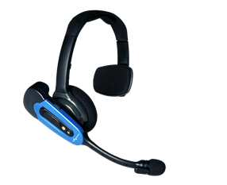

RS507 Bluetooth Ring Scanner
Each Operator would be issued a Motorola RS507 Bluetooth ring scanner for the scanning of location, tote and order barcodes. The small, lightweight Bluetooth scanner is worn on the finger
Figure 3 Motorola RS507 Bluetooth Ring Scanner Assembly
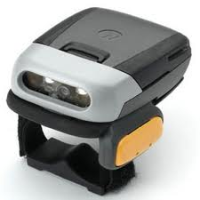

Pick to Voice Hardware List
Dematic will provide the following Pick to Voice hardware:
System Quantity | Description
45 | Vocollect A710 Voice Terminal
90 | Vocollect A710 High Capacity Battery
45 | Vocollect SRX2 Bluetooth Headset
90 | Vocollect SRX2 Bluetooth Battery
45 | Motorola RS507 Triggered Bluetooth Ring Scanner, Large Finger Strap and Small Finger Strap
91 | Motorola RS507 Bluetooth Ring Scanner Battery
49 | A710 Belt with Clip
8 | 6-Terminal A700 Charger and Power Supply
4 | 12-Battery A700 Charger and Power Supply
3 | 20-Bay SRX2 Battery Charger and Power Supply
2 | SRX Maintenance Kit
1 | Headset Windscreens (Bag of 20)
12 | 8-Bay Motorola RS507 Scanner Battery Charger
2 | Motorola RS507 Ring Scanner Finger Straps Assembly (20) Pack
2 | PC Connection Cable
2 | Wireless Listening Kit

Documentation
- This Director IT 7.0 Functional Specification document
- Host Interface Specification
- User Manual

Training
Four Director IT 7.0 training sessions will be conducted:
Operator Training: The Operator training is focused on the operational procedures and includes a detailed individual operator training including template creation (if applicable) assistance and basic fulfillment processing. Dematic will train the designated trainers and will provide assistance as the trainers train other pickers in the facility.
Needed items: A download from WMS and corresponding container labels. Access to the fulfillment area.
Application Training: The Application training will cover a review of the Director IT 7.0 applications and is best held in a classroom environment with a screen projector to display the instructor’s laptop on an overhead screen. The Application Training consists of General concepts training as well as demonstrating the usage of all the pertinent screens and menus. This covers only the usage of the Director IT 7.0 application.
Needed items: Classroom, chairs, tables, projector (to project a laptop screen), network connectivity to the server and standard electrical plugs.
Administrator Training: The Administrator training will cover a review of the physical equipment and Administrator functions. It is best held at a workstation PC near the voice equipment. (Minimal training of application screens are conducted in this session, if application training is needed, personnel should attend the Application Training session also.)
Needed items: Access to a workstation near the voice equipment.
VoiceArtisan Developer Training: The VoiceArtisan Developer training will cover the basics of making dialog and minor logic changes to a VoiceApplication. Previous knowledge of the Python scripting language and the Eclipse IDE are preferred.
Needed items: Classroom, chairs, tables, projector (to project a laptop screen), network connectivity to the server and standard electrical plugs.
Informal Training: During the startup week the Dematic associates on-site will monitor the operations and can answer questions if needed. Please, utilize these resources while available to ensure that all questions are answered, as it is much easier to train in person than over the phone.

System Architecture
This section provides an overview of the Director IT 7.0 computer system.

Computer Architecture
The Director IT 7.0 computer system consists of the virtual server and Talkman devices.
Figure 4 Computer Architecture Illustration

Functional Description
This section of the document provides detailed descriptions of the functionality provided by Director IT 7.0.

Description of Operation

WMS and Dematic System Communication
The WMS (DLx 2004.2) and Dematic system will communicate over a Lifetime Brands provided LAN using Dematic’s MessageDistributor which is a custom protocol utilizing TCP/IP Sockets.
:INFO: For detailed information about the Host Interface, please reference the Host Interface Specification.

PickCart Building
It is the responsibility of the Lifetime Brands system to pre-build each PickCart and stage the cart for the next available Voice Operator. The cart build process will include the identification of the following:
- Unique PickCart ID
- Order numbers on PickCart
- Unique ID of each order carton
- Location of the order carton on the cart (shelf # and carton sequence from left end of the cart as viewed by an operator)
Figure 5 Built PickCart with Cart ID Barcode shown in Upper Left Corner
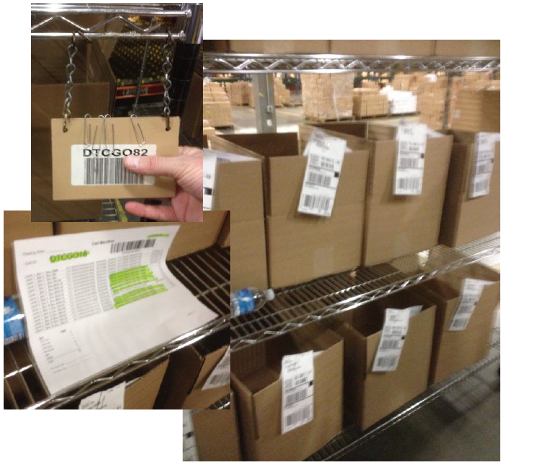
Upon the completion of the cart building process, a corresponding dataset will be transmitted to the Dematic system. In addition to the above data, the PickCart download will include:
- A list of each pick requirement for each order carton ID
- Line item number
- Location ID from which the pick is to be made
- Quantity required for that specific order
- Description of item found in that location
- Special Handling Flags (i.e.: Fragile Product)
- Pick sequence by pick location
NOTE: Allows the WMS to establish the pick path for each cart.

Operator Log-in and Log-out
Prior to beginning work, each voice Operator must obtain a Talkman unit. The operator logs into the system by using the menu on the voice unit to find their team and then their operator ID within that team. The operator will be asked to voice their password to confirm that the operator ID chosen is the correct one.
Next, the operator will then log into a pick zone via one of the following methods:
- Voicing a pick zone followed by “ready” upon logging into the system.
- Saying “Change Zone” if already logged in to a pick zone and there is a need to switch to a different pick zone. The voice unit will prompt the operator to voice a pick zone. The operator will voice a pick zone and then “Ready”. This command can be used at any prompt.
- The available picking zones will be Mikasa, MikCom, Fred, DTC, Kohls and Wholesale
- Additional non-picking zones will include Break, Bathroom, Cleanup and Meeting. These zones are used for tracking indirect labor time only.
:INFO: An operator may sign into only one zone at a time. Merging zones will be disabled for this project.
When the operator’s shift is done they simply notify the system they are logging off the system with the “Sign Off” command. They will then return the Talkman unit to a charging cradle.

PickCart Processing

Induction
When the operator logs into a valid Pick Zone and requests “Next Cart”, Director IT 7.0 will make a request to the WMS, the WMS will send the top available Cart Manifest ID & Built Stage Location. The operator will be directed first to the Built Stage Location. After confirming that they have arrived at the location by saying “ready”, the operator will be told the first half of Cart Manifest ID. They will scan the Manifest ID barcode to confirm that they are picking up the correct cart. The operator will have the ability to override the suggested Cart by scanning any other Cart Manifest ID instead.
Upon induction of a cart, a CARTSTATUS message with a type of DIRECTSCAN (a cart scanned), WORKREFUSAL (cart suggested by WMS, but other cart scanned), or AUTOASSIGNED (cart suggested by WMS and accepted by operator) will be sent. A screen will be included to show all inductions and suspensions, associated operator, and the corresponding induction types.

Anomaly Induction, Cancel Process and Suspension
A user can use the command “Hot Carton” to remove a carton from a cart and induct the carton to be picked by itself. The carton will be picked through the normal pick process, but the pick distribution described in section 4.1.4.4 will be skipped, as will the dropoff process described in Section 4.1.5.
The “Cancel Carton” command will remove a carton from a cart and ShortComplete all unpicked items for the carton.
The WMS may also send a request to cancel any previously downloaded cart, carton or lineitem. If the affected order(s) have not yet been inducted, the request will be processed. Otherwise, the request will be rejected.
A work assignment can be stopped during the picking process by using the “suspend” command. In order to resume the work assignment, the cart manifest or carton id should be scanned.
If a work assignment is not suspended, and needs to be transferred to a different operator for completion, intervention through the GUI by a supervisor is required.

Picking
The Operator is now directed to the first location on the pick path with a pick requirement for one or more of the orders on the cart. The voice will say “Aisle dash Bay dash Shelf Position” for the location the operator will visit to fulfill the order. The full location will be voiced for the first pick of the order in a pick zone. Only the changed portion of the location will be voiced for the remaining locations, but the shortest location voiced will consist of the shelf and position (i.e. if “D3273A” is the first location and the second location is “D3273D”, the first location is voiced as “delta three dash two seven dash three alpha” and second location will be voiced as “three delta”. If the next location is “D3274B”, the system will voice “dash two seven dash four bravo”).
To hear the location again, the operator can say “Say Again” to make the voice unit repeat the last statement (in this case the shortened location). Say Again can be used at any point to listen to the last prompt. The “Location” command will cause the system to say the full non-truncated location value. The Operator will be asked to scan the corresponding product’s UPC, Inner Code or Case Code upon their arrival. If an incorrect barcode is scanned, the Operator is told of the error and the original instructions are repeated.
The initial pick prompt will consist of the shortened location followed by the word “scan” and then the pick quantity.
Figure 6 Typical Pick Locations
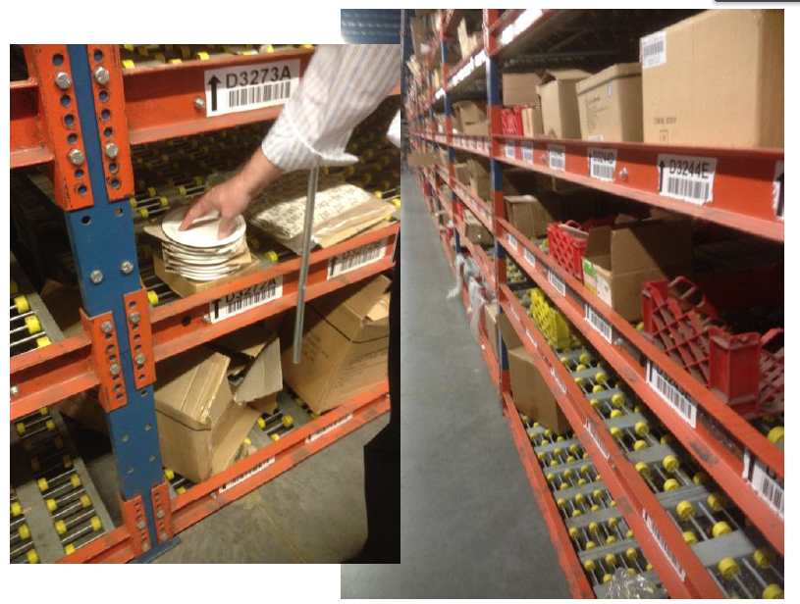
When the correct product barcode is scanned, the Operator is told “pick” followed by the quantity to be picked. They will repeat the quantity and speak ‘ready’ when the pick has been completed.
:INFO: If a Special Handling flag has been set in the order download for this pick, the system will prompt the Operator with a special prompt. There are no further instructions or functions by the Dematic system with respect to the Special Handling flag.

Distribution
Upon hearing the ‘ready’ response, the Operator is now directed through the distribution of the picked items to the order cartons requiring that Item. This is done on an order by order basis. The System will identify to the Operator the cart position of the first carton requiring that item. The Operator is also told the quantity to be placed in the carton and is asked to scan the carton ID to confirm the placement of that quantity of the item in that carton.
If an incorrect order carton ID is scanned, the Operator is notified of the error and the original instructions are repeated. The Operator must remove the items from that carton. When the correct carton ID is scanned the distribution requirements for the next order carton requiring that item is provided to the Operator and the process is repeated. When the last distribution requirement for that picked item has been confirmed, the Operator is directed to the next pick location.

Pick Options / Insufficient Stock Handling
Should the Operator find that they are unable to pick the entire pick requirement due to a large pick request or insufficient stock in a location, they have several options.

Skip Slot
The “Skip Slot” command is used to move the current location to the end of the picklist.

Chop Up
The “Chop Up” command is used to split the pick into more manageable chunks. For example, if the quantity requested is 16, but the picker can only hold 10, the operator would confirm “one zero, chop up”. This will initiate the distribution process for the 10 items. After this distribution, the operator will be prompted to pick the remaining 6 items.

Partial
The “Partial” command is used to pick less than the full requested quantity, but keep the line item open to further picking. If the requested quantity is 7, but only 2 items are available at the location, the operator can respond with “two, partial”. This will initiate the distribution process for the 2 items. The remaining request for 5 items will be moved to the end of the picklist. When the partial command is used, the system will request a reason for the partial. Valid responses are “Damage”, “Wrong Product”, or “No Stock”. This reason code is passed up to the WMS in the ITEMSTATUS message.

Short Pick
The first option to short a pick request is to perform a short pick from the location. Upon being provided the specified pick quantity, the Operator will pick what is available and will respond with the actual quantity picked versus the requested “ready” response. Upon hearing the quantity response, which is less than the requested response, the system will ask the Operator to confirm that they intend to make a short pick.
Upon hearing a confirmation response from the Operator, the system will proceed to the distribution process for any picked items.

Empty Slot
The “Empty Slot” command is used when there is no product to scan in a location. Upon confirming the Empty Slot request, the user will be asked if they want to perform a partial or short pick of the location. Depending on their response, this will be treated as a “zero, partial”, or “zero, ready” response.
:INFO: When the Partial or Short Pick command is used, orders will be filled from lowest number of picks to highest number of picks. This is intended to complete the maximum number of cartons.
:INFO: When any of the commands in section 4.1.4.5 are used, a corresponding ITEMSTATUS message is sent.

Short Distribution
The system will provide distribution instruction to the Operator as if there was no ‘short pick’. The Operator will perform and confirm each full distribution in the same manner as described above. When the Operator is given a distribution requirement that cannot be fulfilled by the remaining quantity of the item they hold, they will use the “Change Quantity” command before scanning the order carton’s ID barcode. The system will ask the Operator to confirm they are performing a ‘Short Distribution’ to that order carton and confirm the quantity put into the carton. Upon receiving that confirmation, the Operator will be directed to the next pick location.
:INFO: Upon receiving a ‘Short Distribution’ confirmation, the Dematic system will short that order and any other order on the PickCart that was to receive that item, but did not. The system will upload a pick confirmation to the WMS reflecting the shorted quantity in the ‘Quantity Confirmed’ field.

PickCart Completion

No Short Picks
When the last distribution of the last item picked for the cart has been confirmed, Director IT 7.0 will send a message to the WMS asking for the PickCart drop location. The Operator will be directed by voice to the PickCart drop location. The Operator will have the ability to override the drop location. Upon placing the PickCart in the location, the Operator will either start a new cart or log off the system.
Figure 7 Piece Pick Pack Staging Area for PickCarts
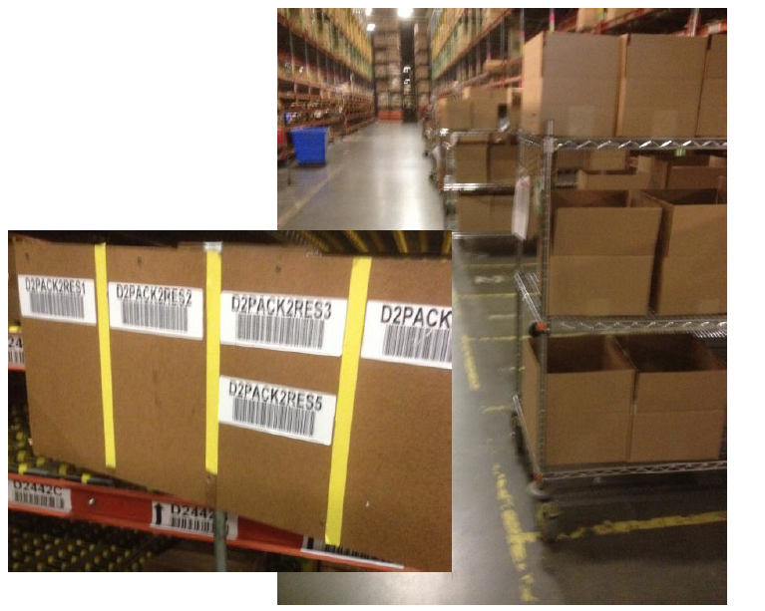

Short Picks
If there was a short pick confirmed for one or more orders on the PickCart, the voice system will direct the Operator to the Hospital area. Once they are in the Hospital area the Operator will be directed to offload any order cartons where a short pick was recorded. The system will identify the cart position of a shorted carton and will ask the Operator to speak “ready” when the carton has been removed. This is repeated for each carton with a short pick. When the removal of last carton with a short pick has been confirmed the Operator, Director IT 7.0 will send a DROPCARTREQUEST message to the WMS, the WMS will respond with the PickCart drop location. The Operator will have the ability to override the drop location.
In the unlikely case that all cartons on the cart were delivered to the hospital, the system will bypass the DROPCARTREQUEST and direct the operator to deliver the cart to the “Cart Build Area”.

Pick Confirmation Uploads
Upon the confirmation of drop to the Pack Staging Location, the Dematic system will upload a pick confirmation for the orders to the WMS. At a minimum these files will include the following:
- PickCart ID
- Order numbers on PickCart
- Unique ID of each order carton
- Pick location
- Quantity requested
- Quantity confirmed
- Line item Status
- Operator ID
- Date and time stamp

Expert Pick Modes
There are several settings configurable by operator which can streamline the dialog to remove confirmation steps from the fulfillment process. Care should be used with enabling these settings, as skipping the confirmation steps can result in increased errors.
- Quantity Expert– The operator is directed to the warehouse location and told the amount of quantity to pick from the location. The operator then verifies the pick by scanning the product. If the operator wants to short a pick they will say “Change Quantity”.
- Quantity Non-Expert– The operator is directed to the warehouse location. The operator then verifies that they are at the correct warehouse location by scanning the product. Once verified the system then tells the operator the amount of product to remove from the warehouse location. The operator confirms the pick by saying ‘x ready’.
- Cluster Expert– The system indicates what quantity belongs to what order. The operator places the proper quantity on the Carton and states ‘ready’ to acknowledge the action.
- Cluster Non-Expert – The system indicates what order the quantity should be put onto. The operator verifies that they are using the correct Carton by scanning the Carton ID.

Location Naming Conventions
The pick location will vary in composition, but will always contain an aisle, bay and shelf position, separated by dashes.
TODO: The cart naming convention is described below:
TODO: The cart build staging location naming convention is described below:
TODO: The cart drop off location naming convention is described below:

Performance Description
The Director IT 7.0 computer system software will be designed to operate continuously seven (7) days per week, twenty-three (23 3/4) hours per day.

Director IT 7.0 Response Times
The Director IT 7.0 System response time performance will provide:
Response time expectation - based upon a maximum transaction rate of 10,000 order lines per hour and 1,000 inducts/hour the system shall fulfill the following response requirements in responding to the picker interface:
Normal Load — Sub-Second response lime to picker activity - 99% of the time.
Peak Load — Response time to picker activity within 3 seconds - 1% of the time.
Running real-time reports during production contributes to system loads and may create peak load conditions.
:INFO: When using a Virtual Machine, response times cannot be assured, as many items, due to the VM hardware, are beyond Dematic control. However, the expectations above still apply.

Data Storage and Clean Process
Director IT 7.0 is not intended to provide long-term storage of operational data. However, Director IT 7.0 will maintain historical operator statistics data for up to 14 days.
Director IT 7.0 is not designed to store large amounts of historical data and maintaining a large amount of historical data can impact system performance. Director IT 7.0 is configured to automatically purge unneeded data from the system.
At 2:00 AM (or at another time mutually agreed upon between Lifetime Brands and Dematic) the Director IT 7.0 computer system clean process is automatically run. The clean process requires 1/4 hour to complete. This process cleans up the database, log files, and internal processes. Data that is 14 days old or older is removed.
Although the clean process may be set up at a time other than 2:00 AM, the time can only be set by qualified Dematic personnel and should be agreed upon prior to system acceptance (i.e., if the process is set to run at 2:00 AM, it will run at 2:00 AM every day).
Description | Duration
Retention of completed tote/carton | 1 day
Retention of not completed tote/carton | 7 days
Retention of log data | 14 days
Retention of history data | 14 days
Analytics data | 200 days

System Backup and Restore
Director IT 7.0 will be installed on the Lifetime Brands provided virtual server. Management, backup, and disaster recovery of the VM images is the responsibility of Lifetime Brands.

Graphical User Interface
:INFO: The following descriptions of various GUI screens is not intended to be a comprehensive list of all screens, but rather an overview of some more commonly used screens. Please note that the screens in Section 6.6, 6.7 and 6.8 are part of the Analytics Module slated for install during the second phase of the project.

System Overview
The System Overview screen lists the zones in the system. Click a hyperlink in the first pane to show the lines detail in the second pane. Click a Task in the second pane to display the task detail in the lower pane.
Figure 8 System Overview
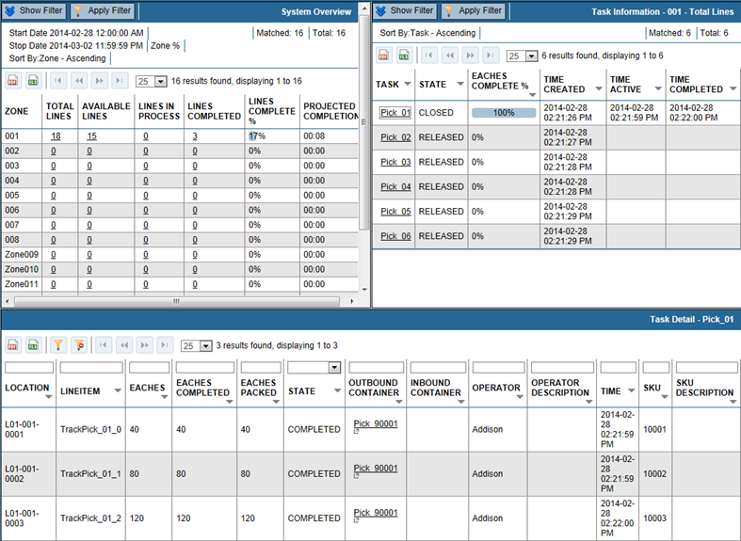
Click a container hyperlink in the lower pane to display the related screen.

Item | Description
Zone | ID of the zones in the system.
Total Lines | Total number of LineItems in the zone.
Available Lines | Number of LineItems waiting to be processed for the zone. This does not include any LineItems that are currently in process.
Lines in Process | Number of LineItems currently in process.
Lines Complete | Number of LineItems that have been completed.
Projected Completion | Estimated hours and minutes required to complete the work in the zone.
Task | The ID of the work that needs done at the location.
State | Received – Task has been downloaded by the host but is not able to be processed.  Released – Task is able to be processed.  Active – Task is currently in process.  Closed – Task is complete.
Eaches Complete % | Percent of eaches complete for the task.
Time Created | Date/time stamp of when the task was created.
Time Active | Date/time stamp of when the task became active.
Time Completed | Date/time stamp of when the task was completed.
Location | Physical location in the warehouse the selected task is for.
LineItem | ID for the LineItem.
Eaches | Quantity of eaches for the location.
Eaches Completed | Quantity of eaches packed for the location when the container is complete.
Eaches Packed | Current quantity of eaches packed.
State | State of the location, such as Active.
Outbound Container | In a put system, the outbound container is assigned to the location and product is put in it for a store.  In a pick system, the outbound container travels through the zones and product is placed in it for an order.
Operator | Operator responsible for the event.
Operator Description | Description of the operator, if available.
Time | Date/time stamp of the event, such as when the container was completed.
SKU | Product identifier of the LineItem.
SKU Description | Product description.

System Progress
The System Progress screen displays order fulfillment progress sorted by zone.
Figure 9 System Progress
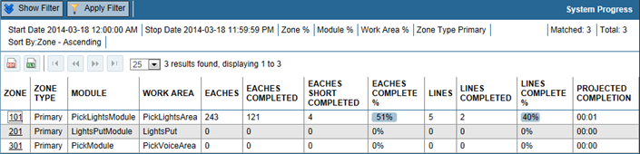
Click a hyperlink in the Zone column to display the Zone Progress screen with that zone's tasks displayed. To return to the System Progress screen, click the browser's back button.
Item | Description
Zone | ID of the zone hyperlinked to display the Zone Progress screen.
Zone Type | Type of zone, typically Primary, but could be Secondary in a voice-based area.
Module | ID of the module the zone is in.
Work Area | ID of the area.
Eaches | Number of items required for tasks in the zone.
Eaches Completed | Number of items picked for tasks in the zone.
Eaches Short Completed | Number of eaches that were shorted instead of picked, when the task is complete.
Eaches Complete % | Percent of required items that have been picked in the zone.
Lines | Number of hits, or locations the operator must visit, to pick the items.
Lines Completed | Number of lines completed.
Lines Complete % | Percent of lines completed.
Projected Completion | Remaining hours:minutes estimated to be needed to complete the picks.

Zone Progress
The Zone Progress screen identifies high-level information pertaining to each task for the zone or wave. The line items for each task are displayed along with the current state of each line item.
Figure 10 Zone Progress
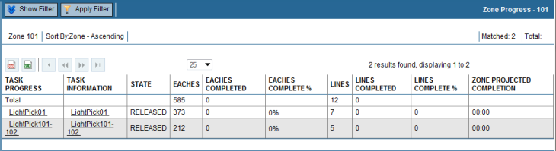
:INFO: The Zone Progress screen is accessed through the System Progress screen.
Click a hyperlink in the Task Progress column to display the Task Progress screen. To return to the Zone Progress screen, click the browser's back button.
Click a hyperlink in the Task Information column to display the Task Information screen. To return to the Zone Progress screen, click the browser's back button.
Item | Description
Task Progress | Link for displaying the task on the Task Progress screen.
Task Information | Link for displaying the task on the Task Information screen.
State | Task state:  - Received – Task has been downloaded by the host but is not able to be processed  - Released – Task is able to be processed  - Active – Task is currently in process  - Closed – Task is complete
Eaches | Quantity for a LineItem.
Eaches Completed | Total number of eaches picked.
Eaches Complete % | Percent of eaches complete.
Lines | Number of lines for the task.
Lines Completed | Total number of LineItems that have been completed.
Lines Complete % | Percentage of LineItems that have been completed.
Zone Projected Completion | Estimated number of hours and minutes (hh:mm) remaining to complete all outstanding LineItems in the zone. As this is an estimation, seconds are not considered, therefore 00:04 would be shown whether the actual calculation was 4 minutes 47 seconds or 4 minutes 10 seconds.

Outbound Container - Pick
The Outbound Container - Pick screen displays all outbound container destinations. Select a container in the upper pane to display the related detail for it in the lower pane.
Figure 11 Outbound - Pick
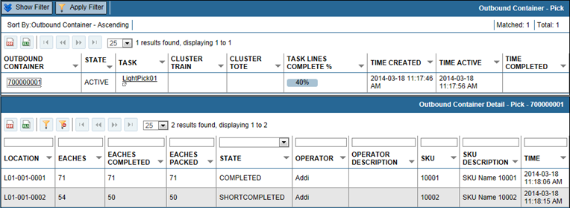
Select a hyperlink in the Task column to display the progress for the task on the Task Information screen.
Column Descriptions Outbound Container Pick
Item | Description
Outbound Container | ID of the container that picked product is placed in.
State | State of the container such as Created or Active.
Task | Task is the same as an order. It is the set of line items that need picked for an order.
Cart ID | Cart ID if the container is part of a cart cluster.
Task Lines Complete % | Percent of line items picked for the task.
Time Created | Date/time stamp for when the container was created.
Time Active | Date/time stamp for when the container became active.
Time Completed | Date/time stamp for when the container was marked completed.
Column Descriptions Outbound Container Detail - Pick
Item | Description
Location | Physical location in the warehouse.
Eaches | Quantity for a LineItem.
Eaches Completed | Quantity of eaches picked for the LineItem when the container is complete.
Eaches Packed | Current quantity of eaches picked for the LineItem.
State | Current state of the container, such as Created or Active.
Operator | ID of the operator who picked the eaches.
Operator Description | Description of the operator who picked the eaches.
SKU | Product identifier.
SKU Description | Product description.
Time | Date/time stamp for the current state.

Location Information - Pick
The Location Information - Pick screen lists the pick locations in the system and identifies any locations that have a short.
Figure 12 Location Information - Pick
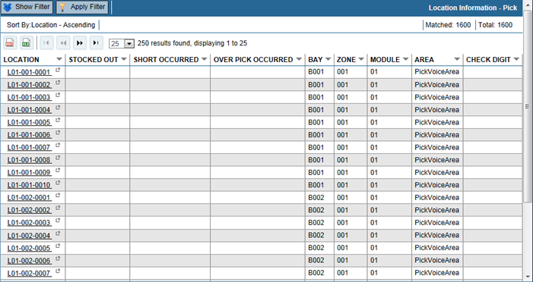
Click a hyperlink in the Location column to display the progress for the location on the Task Progress screen.
:INFO: The number of records loaded into memory, and able to be displayed in the table, is restricted according to the value set during system configuration. By default, the limit is 250 records.
Item | Description
Location | Pick location ID in the warehouse.
Short Occurred | Yes or blank. Will be Yes if an operator shorted a pick at the location.
Bay | Bay ID the location is in.
Zone | Zone name the location is in.
Module | Module ID the location is part of.
Area | Area name the location is part of.
Check Digit | In a voice system, the digits that can be spoken by the operator to confirm the location.

Picking Reports

Statistics By Operator
The Pick Statistics by Operator report includes order fulfillment counts grouped by operator. The last page of the report contains the report totals.
Figure 13 Pick Statistics By Operator Report
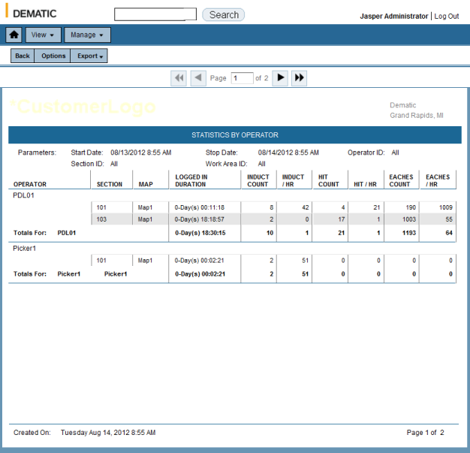
Figure 14 Statistics by Operator - Last Page
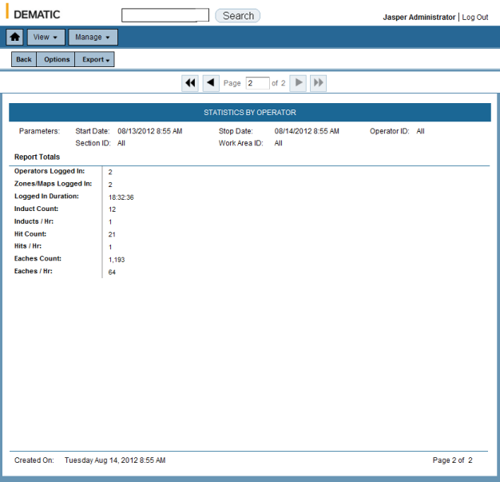
Report Parameters:
- Start Date/Time
- Stop Date/Time
- Operator ID
Report Contents:
Operator ID - The operator's ID, it may be a number or part of their name. Subtotals are provided for each operator (when All is selected).
Section - The zone the operator was logged into.
Map - The name of the map that was active at the time.
Logged in Duration - The days, hours, minutes, and seconds that the operator was logged in for the instance.
Inducts - Number of inducts for the logged in duration.
Inducts / Hr - Average number of inducts per hour for the logged in duration.
Hit Count - Number of hits (locations picked) for the logged in duration.
Hit / Hr - Average number of hits per hour for the logged in duration.
Eaches Count - Number of eaches (number of items picked) for the logged in duration.
Eaches / Hr - Average number of eaches per house for the logged in duration.
Report Totals - When All is selected for Operator ID, the Report Totals are calculated combing the duration and counts of all operators for the period.

Statistics By Section
The Statistics by Section report includes order fulfillment counts and times organized by section (zone). The last page of the report contains the totals.
Figure 15 Pick Statistics By Section Report
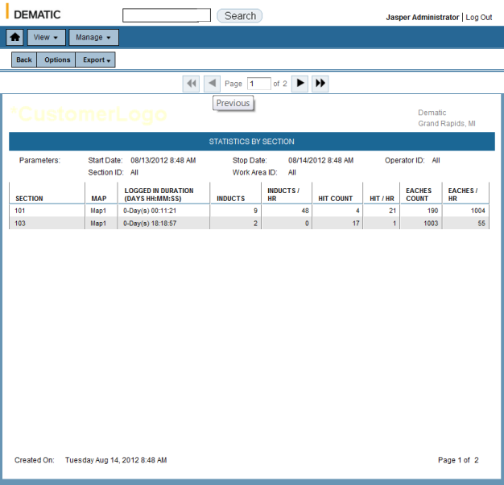
Figure 16 Pick Statistics by Section - Last Page
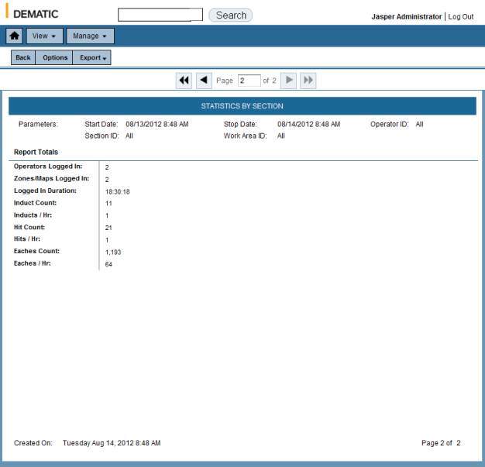
Report Parameters:
- Start Date/Time
- Stop Date/Time
- Operator ID
Report Contents:
Section - The zone that was logged into. Subtotals are provided for each zone.
Map - The name of the map that was active at the time.
Logged in Duration - The days, hours, minutes, and seconds that the operator(s) was logged in for the instance.
Inducts - Number of inducts for the logged in duration.
Inducts / Hr - Average number of inducts per hour for the logged in duration.
Hit Count - Number of hits (locations picked) for the logged in duration.
Hit / Hr - Average number of hits per hour for the logged in duration.
Eaches Count - Number of eaches (number of items picked) for the logged in duration.
Eaches / Hr - Average number of eaches per house for the logged in duration.
Report Totals - When All is selected for Operator ID, the Report Totals are calculated combing the duration and counts of all zones for the period.

Picking KPIs
The Picking KPIs provide historical data grouped on several tabs.
Performance Information: Data list of the areas and rates for each.
Figure 17 Performance Information
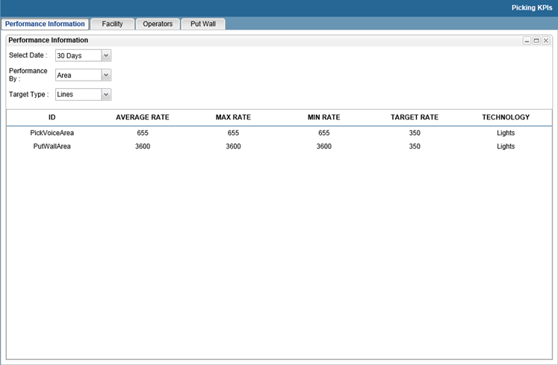
Facility: Bar charts of completed lines, eaches, shorted SKUs, and work minutes.
Figure 18 Facility
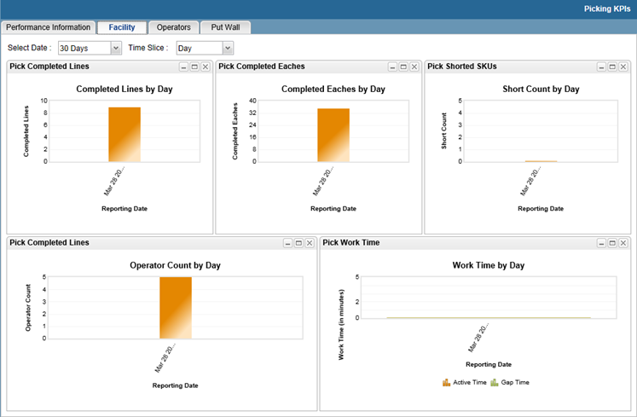
Operators: Bar charts of completed line sand pick rates, and line graph showing operator utilization.
Figure 19 Operators
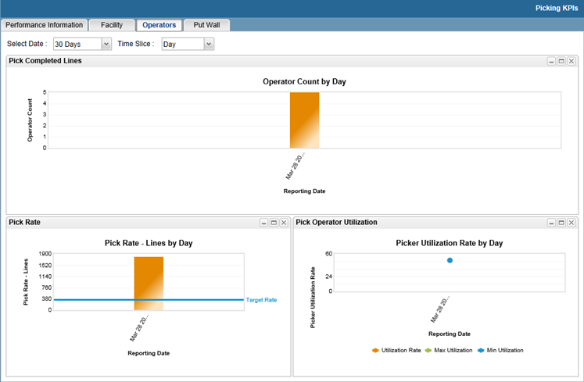
Each tab has selectable parameters such as Select Date and Time Slice. The displayed data updates after each selection.
The pods can be rearranged by dragging and dropping and using the icons at the top-right of each pod. To minimize a pod, click the minimize icon in the upper right corner of the pod. This collapses the pod to display only the title bar. To maximize a pod to fill the screen, click the maximize icon . To restore a pod to its original size, click the restore icon . A pod can be closed to make room for the other pods to be larger. Pods can also be dragged and dropped into a new positions. Reloading the screen restores all the pods to their default size and location.

Picking Dashboard
The Picking dashboard provides an overview of the picking module operations and progress.
Figure 20 Picking Dashboard
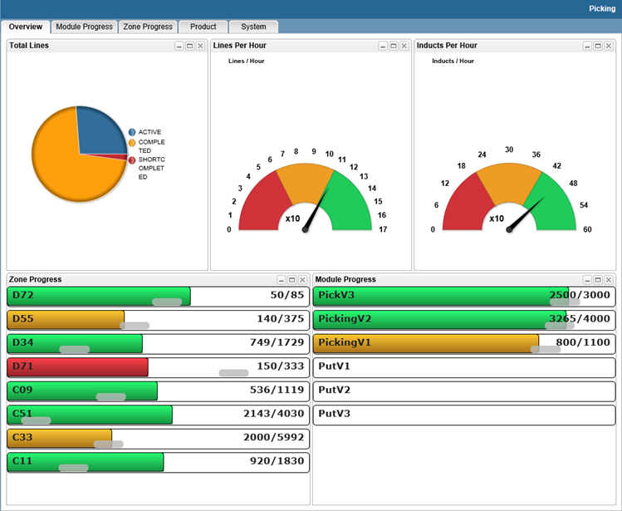
The charts use color to indicate how a zone or module is doing compared to baseline rates within the database. The line between amber and green is the baseline average. When no data is available for a pod, this is indicated adjacent to the pod title.
Pods for each tab are listed below:
- Overview:
Total Lines: The pie chart shows the breakdown of overall line status. Hover over a slice to see the percent.
Lines Per Hour: This speedometer gauge shows the average lines per hour for the picking system.
Inducts Per Hour: This speedometer gauge shows the average inducts per hour for the picking system.
Zone Progress: Lines completed of the total lines for the top three zones.
Module Progress: Lines completed of the total lines for each module.
- Module Progress:
Module Progress: Lines completed of the total line for each module.
Eaches Progress: Eaches completed of the total eaches for each module.
Task Progress: Tasks completed of the total tasks for each module.
- Zone Progress:
Zone Rates: This speedometer gauge indicates inducts, eaches, and lines per hour for the top three zones.
Zone Progress: Lines completed of the total lines for the top three zones.
Show Operators In Zones: Number of operators logged into each zone.
- Product:
Product Status: The count of shorted items.
Queues: The count of suspended container destinations.
- System:
Host Information: The count of lines downloaded from the host and the date and time when it was last downloaded.

Scorecards
The Scorecards Main Screen displays the scorecards for all shifts and the most recent seven days. The data used for scorecards and measurements is historical. As each day’s shift is completed, the live data is moved to the historical databases, and is then available for use by the scorecards.
Figure 21 Scorecards Main Screen
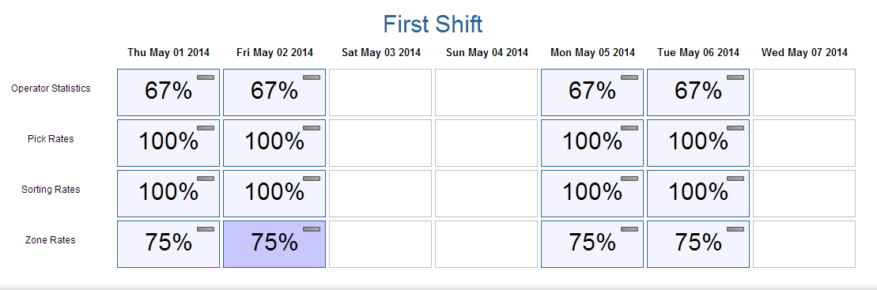
Two indicators are shown on each scorecard: A 30-day trend icon and percent of scorecard measurements that passed. Clicking a scorecard displays its measurements. Two indicators are shown for each measurement: a 30-day trend icon for the measurement and red or green coloration to indicate pass or fail. The linear regression model is used for the trending.
An example scorecard is shown below:
Figure 22 Example Scorecard
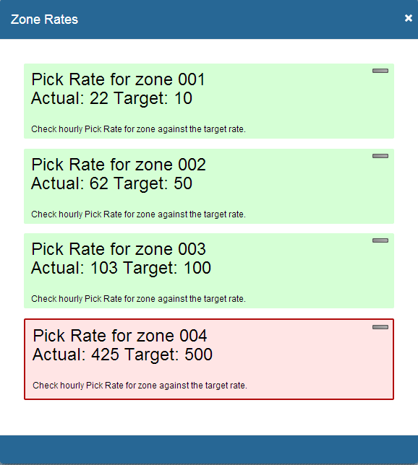
A variety of custom scorecards may be created using the KPIs that are tracked by the Analytics module. These KPI include:
- Completed Lines
- Completed Eaches
- Inducts
- Lines per Trip
- Eaches per Trip
- Shorted SKUs
- Skipped Slots
- Pick Rate
- Pick Rate/Target Rate
- Login Count
- Logged In Time
- Order Completion Time
- Order Volume

Appendix

Appendix A – TCP/IP Addresses
The TCP/IP network information for the Director IT 7.0 system and associated nodes are listed below.
Description | TCP/IP Address | Subnet Mask | Default Gateway
Director IT 7.0 Primary Server | TBD | TBD | TBD

Signatures
Document Version / Date: __________________________________________
To avoid schedule impact, all parties must sign this specification in the space provided below, and return it no later than 12 PM EST, day, 16-May-2014.
Lifetime Brands | Representative | Representative
Name
Signature
Title
Date

Dematic Corp. | SAE Software Project Lead | Technical Lead
Name | Adam Downer | Tyler Kelsey
Signature
Title | Software Project Manager | Software Engineer
Date

Fourteen days is not a customer configurable item. If requested it can be changed while on-site.

